Andrea Bozic & Julia Willms – Beginning

Technical Rider

The picture below is taken from the right corner:
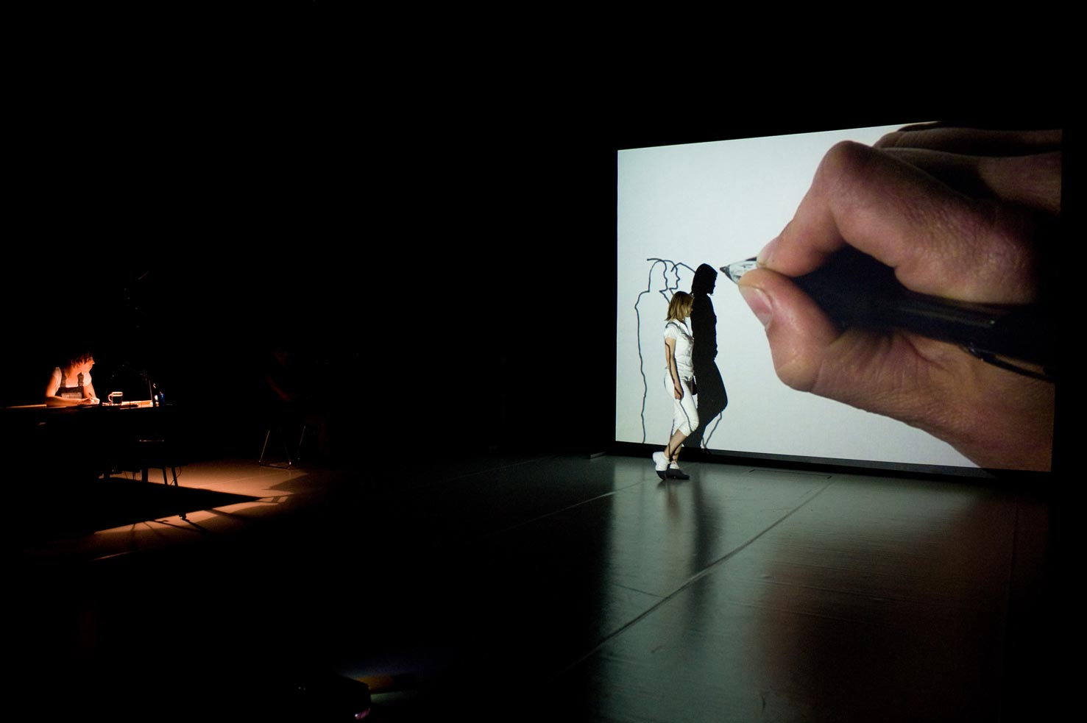

Running time: cca 20 minutes

People who come:
2 performers

People we need:
1 technician to help us set up and run our lights and sound (simple cue)

We take with us:

Video:
1 video camera

Audio:
2 contact microphones (unbalanced ¼“ jack)

Video:

1 video projector , 2000 LM, front-ceiling projection NET
1 video camera tripod
A BNC cable between the projector and the camera
1 video projection screen size 447cm x340cm video/data 4:3, front projection (either with standing legs, so the screen is close to the floor level, or a white background)
1 office/bureau lamp

We need the festival to provide us with:

Audio:
We use the standard P.A.-system of the theatre.
Connection for our contact microphones (2-pole unbalanced with ¼“jack plug)
to the P.A.
2 microphones on stands

Decor and costumes:
A stable wooden table, minimum 1,50 m long (please note that it might get dirty from our paint, which is water based but might stain and we need to drill two long pieces of wood into it)
A stable hard chair (on which Julia can stamp on)

Stage:
Minimum 8m deep, 9 m wide
White dance floor

Light:
Audience light (standard that the theatre uses)
2 x 1kW PC or Fresnel) for Julia’s table

Extra:
Warm water for washing up afterwards, towels.
Electricity cables

! Note: please note that we use black water based paint for drawing. Some of it might spray around the table.

Contact:
Andrea Bozic
Tel: 0031641247527
Email: andboz@yahoo.co.uk

